Heavy Weather Sailing

RS200

Ian Pickard, at the front of the RS200 fleet for as long as we can remember, dispels the myth that his success in heavy weather is down to the size of his beer gut.

For many of us, sailing and racing in strong winds is what it’s all about. This article is aimed at wind strengths when you are fully hiked and spilling wind on the beat, and flat out planning downwind. Regardless of your weight and/or fitness, there are a number of things you can do in terms of boat set-up and boat handling which will make you faster and keep the stick out of the drink! I’ve decided to approach this by starting with a little on boat preparation and then look at beating, running and reaching, finishing with a little on tacking, gybing and mark rounding.

BOAT PREPARATION:
A couple of thoughts: if it can break, it will (control lines, halyards, toe straps); and, if it can come undone, it will (shackles, split rings). Problems which would be an irritation in lighter winds can be catastrophic if it’s blowing, and we owe it to the hard-worked volunteer rescue crews to prevent avoidable breakages. There are a number of things we can do to reduce the risk of problems. Firstly check all standing and running rigging and replace anything that’s frayed or damaged – especially running rigging where it cleats and toe strap ropes where they pull against the metal fixings. Secondly move the knot at the top of your main halyard by a few centimetres to stress different parts of the rope. Thirdly tape all shackles and split rings to stop them coming undone. Lastly ensure your sailing kit is appropriate for the conditions!

UPWIND:
Upwind the key control is the kicker … and you need to use plenty! It bends the mast to flatten the sail and makes it easier to control power with the mainsheet. The cunningham is used to open the upper leech and spill power from the top of the main. Obviously the outhaul needs to be bar tight. The mainsheet needs to be played hard to keep the boat flat – it is faster to have the boat flat and only the aft metre or so of the main filling than to have the boat heeled right over with the main setting nicely. Avoid using the mainsheet cleat if you can to ensure you can release the sheet in the gusts. The jib should be sheeted in tight with the fairleads right at the back of the track. The crew needs to be ready to release the jib if there’s a big gust – 2:1 jib sheets may help by reducing the effort required to un-cleat it. As well as easing the main you can pinch in the gusts, but watch for the big header or you’ll capsize to windward! If it’s wavy you will need to move your weight back to avoid filling up over the bow – crew/helm either side of the thwart – luff hard as the bow comes up the wave and bear away down the back, cracking the jib and main as appropriate. Finally get your bum over the side and try to extend your shoulders away from the boat rather than drop your bum towards the water – shorter toe straps help with this – and have the lighter person lean in to make any control line adjustments.

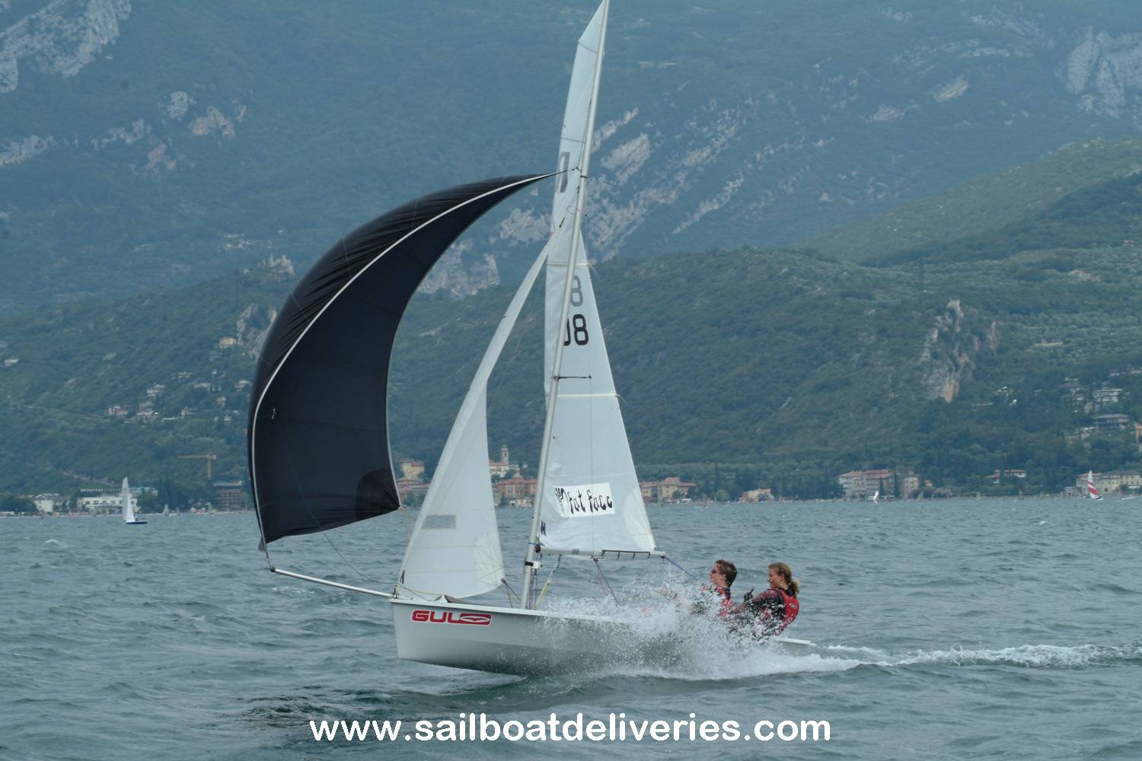
DOWNWIND:
Downwind when it’s really blowing you need to sail a course which keeps the boat flat and driving as hard as you can. This can require some large changes of direction and quite a lot of steering input, especially if it’s gusty, shifty or wavy. It may sound obvious, but stronger the wind blows the more you should bear away, but be ready to head back up again if there’s a lull to keep your speed on. There are a number of things you can do to make the boat more easily controlled. Firstly you must keep the boat flat or you will have little or no steering control. Let plenty of kicker off but keep the main sheeted so the boom is well off the shroud – about half way out. As you can see from the photo, this twists the main which is not only fast but also means that the boat will bear away more easily and the clew end of the boom is higher so it is less likely to hit the water and tip you in. If you ease the main too far with the kicker off, the top will go forward of the mast and can tip you in to windward. The jib should be sheeted so the middle tell-tales are streaming, and can be left like that or played depending on the crew’s confidence. The kite should be sheeted so the luff is just starting to curl and must be eased as the helm bears away and sheeted in as the helm luffs. Communication is critical here – the helm should spend quite a lot of time looking backwards to see what the wind is doing and constantly feed the crew information on the next gust, etc.

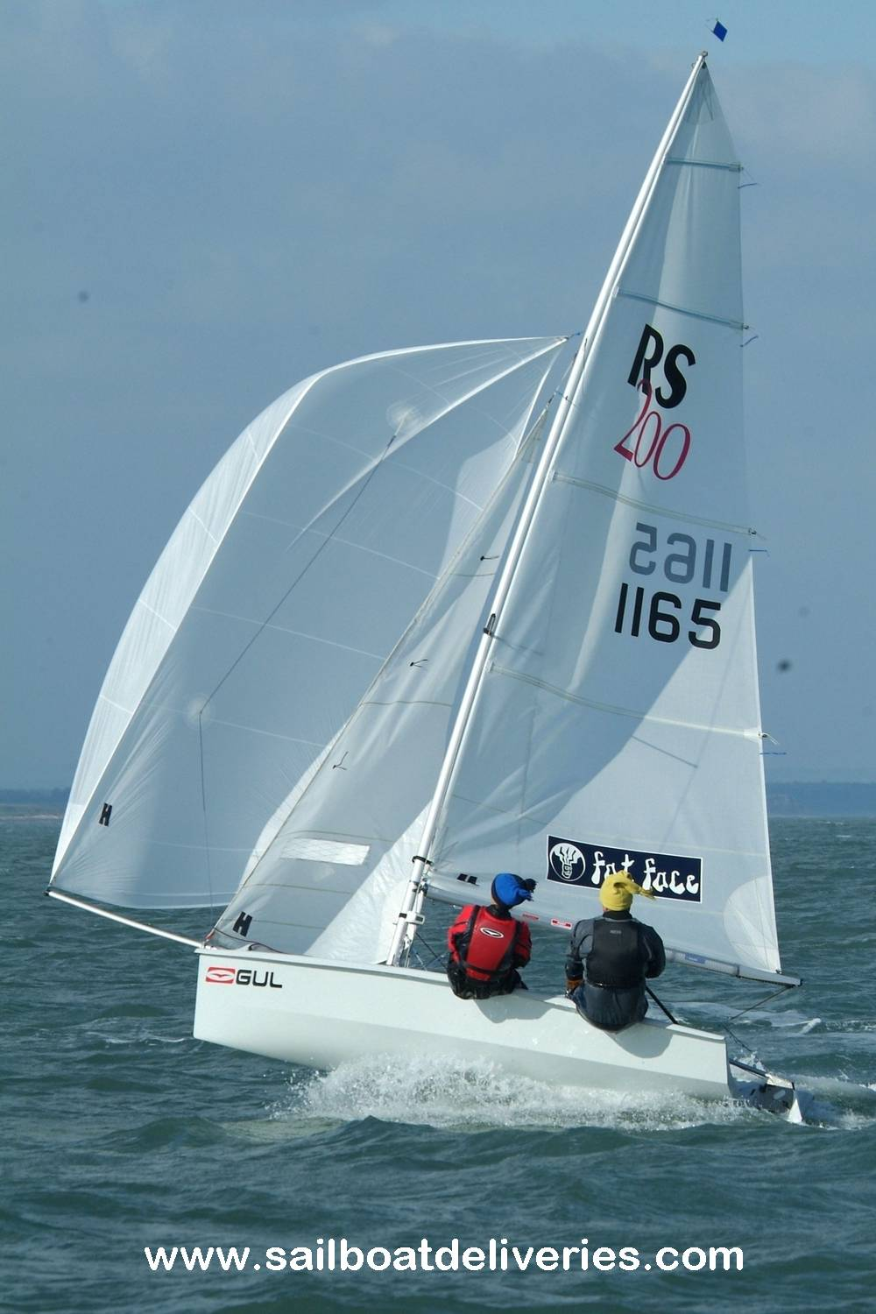
REACHING:
Heavy weather reaching is much loved by those of us who enjoy our beer and curry! There are many spectacular photos around of RS200s reaching but you need to ask yourself a few questions before the start of the reach: can we carry the kite at all; if we hoist it will we be able to drop it again if necessary; what is the risk of capsizing in a gust versus the speed advantage of the kite; is there a boat to leeward who may luff and we would be unable to respond? If you have decided to carry the kite and are overpowered (as in this photo!) make sure the kicker is eased, the outhaul is tight, the cunningham is on hard, and ease the mainsheet until most of the sail is backed – this all provides controllable power in the main, low-down for minimum heeling. If this doesn’t work, ease the jib until it is almost completely flapping. If you’re still overpowered in a gust the crew may be able to curl the front of the kite to lose a little more power, but it must not flog or it’ll drag you over sideways. If you’re still overpowered, drop the kite and try eating more pies!!!

TACKING:
Communication is crucial for a heavy weather tack – the helm must tell the crew what’s coming up, and the crew must shout “no” if there’s any problem! Avoid tacking in the middle of a huge gust, especially if the boat has slowed – the faster you’re going, the easier the manoeuvre, just like gybing. The helm should wait to hear the “click” of the jib sheet being uncleated before starting the tack and should make sure the mainsheet is also out of the cleat. Tacking the boat flat is the best way to avoid a capsize as, should anything go wrong, the main can be eased without the boom hitting the water. Try to get straight into the toestraps out of the tack and aim to come out on a close-hauled course, rather than a fetch or close reach. The crew should not back the jib during the tack, as this will spin the boat around too fast and too far and may cause a capsize.

GYBING:
The majority of heavy weather capsizes seem to happen when gybing. Largely I reckon this can be put down to a lack of preparation before the gybe (including communication), gybing at the wrong time (e.g. with the bow buried in a wave, the boat slow, and huge pressure in the sails), steering too far, or letting the boat heel too much to leeward. So, how do you avoid a swim? The helm should give the crew plenty of warning so they can get set up – cross-cleat the jib on the windward sheet, find the windward kite sheet, make sure their feet are clear, etc. The helm should ensure the kicker is eased to avoid a broach after the gybe. When everything is set, the helm lets the crew know and starts to bear away – a small amount of windward heel will help this, so helm and crew should stay on the side-deck. Try to avoid using the gybing strop if you can – bring the boom across with a Laser-style flick of the mainsheet when it is ready to come, but give the gybing strop a yank if the main looks like it’ll misbehave. As the boom comes across both helm and crew should head for the new windward side-deck, timing their run to keep the boat flat, with the helm centering the tiller as the boom comes over and the crew sheeting the kite in at first (on the old side) then releasing that sheet and pulling the new one so the clew of the kite just flicks the luff of the jib on its way past as it fills on the new gybe. Helm and crew should hit the new windward side-deck as the sails fill and adjust the direction and sail trim accordingly. This takes practice and video-coaching can be a great help. If conditions are really mad, you can always drop the kite and tack around instead, but there’s as much risk of a capsize during drop-luff-tack-bear away-hoist as there is during a well planned gybe (easy for me to say!). Waves can make gybing easier – gybe at maximum speed as you accelerate down the front of the wave when the pressure in the sails is least.

MARK ROUNDING:
You should be aiming to make the mark rounding manoeuvre as easy as possible for the boat. Hence if it’s a bear-away, get set up a boat-length or two before the mark by easing the kicker (and cunningham/outhaul if you can) and uncleating the sheets. Hike hard around the mark to keep the boat flat or ideally slightly heeled to windward to help the bear-away. At the leeward mark drop the kite in plenty of time so you can get set for the beat – getting the outhaul on is the main thing. Leave the kicker (and cunningham) until you’re just around the mark, so you can steer more easily. Again, keep the boat flat so you have control of the steering.

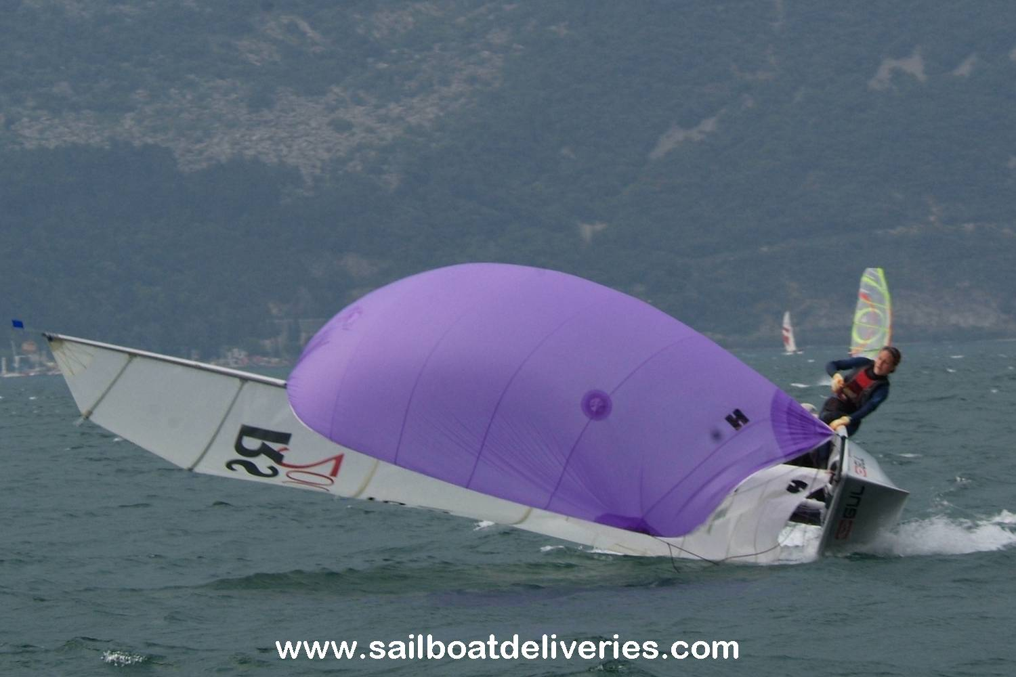
CAPSIZING:
It will all go wrong for everyone once in a while! If it does, don’t panic and try to right the boat as quickly as possible – races have still been won after a capsize! One of you should get on the centreboard quickly to stop the boat inverting while the other drops the kite (if you’ve gone in during a gybe), uncleats both sheets and eases loads of kicker. The RS200 tends to flip over again as you right it in heavy wind and there are two ways to prevent this: the standard “scoop the crew” up method or get the crew to hold the bow as the boat comes up. I reckon the latter is much more effective.

Ian Pickard

